

Brealin Redecker
IST 686
Professor Crowston
12 December 2025

Movies and Dog Breed Popularity: A Case Study Replication
1. Case Study Overview
The case study that I chose to replicate is titled Dog Movie Stars and Dog Breed Popularity: A Case Study in Media Influence on Choice by Stefano Ghirlanda, Alberto Acerbi, and Harold Herzog. The purpose of this study was to investigate whether specific cultural events, in this case the release of movies featuring dogs as a main character or a hero, have a measurable effect on popularity, or dog breed popularity in the United States. The broader aim of this study was to “search for quantitative data in order to better characterize cultural dynamics (Ghirlanda).” The decision to use this topic was driven by “high interest of the general public in both dogs and movies and by the availability of good data (Ghirlanda).”

2. Data Sources
- AKC. 174 observations, 81 variables: (‘Breed’, ‘XYEAR’ )
- moviesAnalyzed. 68 observations, 39 variables ("X", "dog", "breed", "year", "movie", "earnings1",
"earnings", "disney" , "main", "negative", "before1", "before2", "before5", "before10", [15] "after1", "after2", "after5", "after10", "popularity1", "popularity2", "popularity5", "popularity10", "effect1", "effect2", "effect5", "effect10", "excess1", "excess2", "excess5", "excess10", "viewers", "viewers1", "include", "log_total_viewers", "log_viewers1", "pretrend1", "pretrend2", "pretrend5", "pretrend10")

The two data sets were acquired directly from the case study’s data availability. The data had been filtered down already to all of the movies included. The only transformation was adding a log on the viewers and total viewers variables in order to address the skewness.

3. The Analysis
My analysis was broken up into seven main sections following the main events in the case study. In each section I used a frequentist approach, followed by a Bayesian approach to see whether or not the conclusions were consistent. The first section consisted of using one sample t-tests in order to examine the main movie effects. The second section consisted of conducting correlations tests with the release year. The third and fourth sections consisted of running our main linear regressions, the first set using opening weekend viewers and the second using total viewers. The fifth section checked for pre-release trends to either support or reject our regression findings. The sixth section followed a similar sentiment, checking to see if movies with big effects already featured rising breeds. Finally, the seventh section ran wilcoxon rank sum tests in order to determine whether the sign of pre-trend matter in the case of the movie effects.
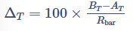
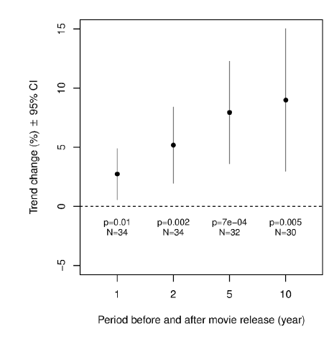
Section 1:
Trend Change Index
FIGURE 2a
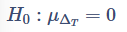
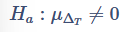
This first section was intended to recreate Figure 2a from the case study, pictured to the right. We recreated this using four one sample t-tests in order to test the effects. In the case study I identified the formula that they used in order to define the trend change index which awas annotated through “Delta_T”. The null and alternative hypothesis for each test in this section is pictured to the right.
The first test using effect1 yielded a p value of 0.009373 and a CI of [0.015, 0.099] which is statistically significant with our alpha of 0.05, therefore we would reject the null hypothesis. This would suggest that our average 1-year trend change is significantly different from zero. The test also yielded a mean of 0.057 which suggests a positive trend of approximately 5.7%. Through the Bayesian approach we yielded a Bayes factor of 4.52, which represents moderate evidence in favour of our alternative hypothesis. The data is 4.5 times more likely under the model where the average effect1 does not equal zero than our null model. The posterior mean yielded 0.053, which was extremely similar to our frequentist mean. The 95% HDI [0.0124, 0.0940] did not contain zero supporting our positive effect.
The second test using effect2 yielded a p value of 0.0014 and a CI of [0.034, 0.129] which is statistically significant with our alpha of 0.05, therefore we would reject the null hypothesis. This would suggest that our average 2-year trend change is significantly different from zero. The test also yielded a mean of 0.0813 which suggests a positive trend of approximately 8.1%. Through the Bayesian approach we yielded a Bayes factor of 24.22, which represents strong evidence for the alternative hypothesis and our data is 24 times more likely under the mode where mean effect 2 does not equal zero. The posterior mean was 0.0763 and our 95% HDI [0.0295, 0.1222] did not contain zero, supporting our positive effect.
The third test using effect5 yielded a p value of 0.00073 and a CI of [0.043, 0.147] which is statistically significant with our alpha of 0.05, therefore we would reject the null hypothesis. This would suggest that our average 5-year trend change is significantly different from zero. The test also yielded a mean of 0.0953 which suggests a positive trend of approximately 9.5%. Through our Bayesian approach we yielded a Bayes factor of 43.13 which represents very strong evidence for our alternative hypothesis and our data is over 43 times more likely under the model that the true mean effect5 does not equal zero. The posterior mean is 0.0892 and our 95% HDI [0.0392, 0.1415] did not contain zero, supporting our positive effect.
The fourth test using effect10 yielded a p value of 0.0047 and a CI of [0.033, 0.165] which is statistically significant with our alpha of 0.05, therefore we would reject the null hypothesis. This would suggest that our average 10-year trend change is significantly different from zero. The test also yielded a mean of 0.099 which suggests a positive trend of approximately 9.9%. Through our Bayesian approach we yielded a Bayes factor of 8.58 which represents moderate evidence for our alternative hypothesis. The posterior mean was 0.0916 and a 95% HDI [0.0263, 0.1546] did not contain zero supporting our positive effect. The HDI for effect 10 is wider than our earlier HDI’s due to further out effects and the passage of time.
Across all four different time windows, dog breeds featured in films exhibited significant increases in their popularity relative to pre-release trends. Using one sample t-tests, looking at the one-year trend change there was a positive mean effect yielding Delta_1 = 0.057 , t(34) = 2.75, p = 0.009 and a Bayes factor of 4.52. This indicates a measurable short-term impact of the movie appearance on the number of registrations of different dog breeds. When running the test for our two-year trend change it was more positive Delta_T = 0.081, t(34) = 3.49, p = 0.01, and a Bayes factor of 24.22 which suggests that the influence of films on the consumer grew beyond just the initial release. The largest sustained effect occurred in our five year trend change, Delta_5 = 0.095, t(31) = 3.75, p < 0.001, and a Bayes factor of 43.13, which indicates to us that breeds that were featured in movies experienced nearly a 10% increase in registrations over this period. The ten-year trend was also positive, Delta_10 = 0.099, t(29) = 3.06, p = 0.005, and a Bayes factor of 8.58, indicating that there was an effect at least a decade after the movie's release.
The results from our t-tests were consistent with the findings in the case study and demonstrate that dog movies exert a statistically significant effect on breed popularity up to 10 years post-release. The strongest effect took place in the 5 year effect size.

Section 2:

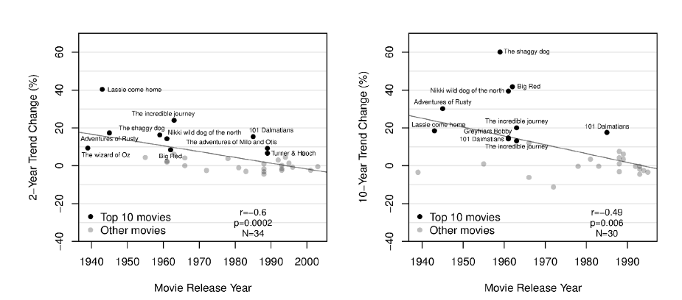
FIGURE 3
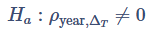
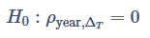
In this second section we want to recreate Figure 2b and Figure 3 by conducting three different correlation tests using the Pearson’s method. The purpose behind these tests is to answer the question: Do newer movies have smaller breed-popularity effects than older ones. The null and alternative hypothesis are pictured to the right.
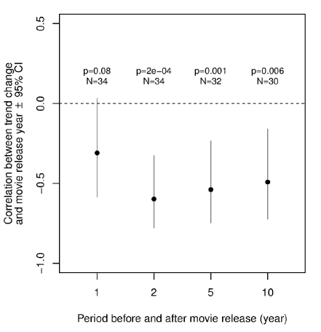
The first correlation test yielded a p-value of 0.00083 which is significantly lower than our alpha of 0.05 and a CI of [-0.7396, -0.2511], which does not contain zero. It also yielded a correlation value of -0.5392. Given the statistical significance of the test, we can interpret that newer movies tend to produce smaller 2-year popularity effects than older movies. Through our Bayesian approach we yielded a Bayes factor of 46.38 which indicates that the data is 46 times more likely under a model where the correlation exists, or p does not equal zero. The posterior mean yielded was -0.461 which is moderately negative and supports our findings from the frequentist approach. The 95% HDI [-0.690, -0.201], does not contain zero, is negative, and is robust which also supports our earlier findings.
FIGURE 2b
The second correlation test yielded a p-value of 0.00146 which is lower than our alpha of 0.05 and a CI of [-0.7472, –0.2342], which does not contain 0. It also yielded a correlation value of -0.5389. Given the statistical significance of the test, we can interpret that this test also implies that newer movies tend to produce smaller 5-year popularity effects than older movies, or that the influence of movies has declined over time. Through our Bayesian approach we yielded a Bayes factor of 29.09 which represents strong evidence for the alternative hypothesis. The posterior mean yielded was -0.455 which is moderately negative and very similar to our effect size 2 findings. The 95% HDI [-0.704, -0.193] does not contain zero and is negative which supports our earlier findings.
The third and final correlation test yielded a p-value of 0.0057 which is lower than our alpha of 0.05 and a CI of [-0.7239, -0.1602], which does not contain 0. It also yielded a correlation value of -0.4920. Given the statistical significance of the test, we can interpret, consistent with our other tests, that older movies continue to produce a larger popularity effect while newer movies show smaller long-term impacts. The Bayesian approach supported these findings with a Bayes factor of 10.04, indicating strong evidence for the alternative hypothesis. The posterior mean was -0.4065, which continues the trend of our previous tests. The 95% HDI [-0.668, -0.117] does not contain zero and is negative, supporting our earlier findings.
By running these three pearson correlation tests, their Bayesian counter parts, and interpreting the results, we were able to examine the influence of movies on dog breed popularity. All three tests yielded negative correlation values, which implies that older movies produced stronger increases in breed registrations compared to newer releases.
When compared to the case study, we find that this replicates what was found. Both the case study and our tests found a clear decline in the magnitude of movie-driven breed popularity effects.

Section 3:
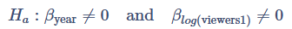
In the third section we run the first of the main key regressions using opening weekend viewers and year as our explanatory variables and effect as our variable we are trying to predict. The null and alternative hypothesis are pictured to the right.
In our first model testing for effect size 1, we yielded a p-value of .02569 which is below our alpha of 0.05 which is statistically significant. The year value yielded a p-value of 0.208 which is not statistically significant, therefore, holding the audience size constant the release year does not provide enough evidence to predict the 1 year trend change. The viewers value yielded a p-value of 0.52 which is also not significant under the alpha of 0.05 and that there is not enough evidence to suggest a relationship between audience sizes and effect sizes. The adjusted R2 is 0.343 or approximately 34% of the variance in effect size 1 is explained by year and log_viewers.
In the Bayesian approach to our first model we yielded a Bayes factor of 1.56 for year, 3.90 for log_viewers, and 3.02 for the interaction between year and log_viewers. However our posterior mean is 0.0374 which suggests a small positive association and our 95% HDI [-0.0082, 0.0848] includes zero which indicates to us that the data does not credibly confirm a positive effect and is not statistically significant. Due to the presence of zero, we are unable to take any meaningful conclusions from this model.
In the second model testing for effect size 2, we yielded a p value of 0.09957 which is not significant under our alpha of 0.05. When looking at our variables we can see that none of our predictors have a significant p-value as well. As a whole our entire model is not statistically significant and there is not enough evidence to draw any conclusions about effect size. The Bayesian model yielded a Bayes factor of 1.22 for year, 1.45 for log_viewers, and 1.15 for the interaction between year and log_viewers. The posterior mean was -0.00188 and the 95% HDI [-0.00597, 0.00216] contained zero. There were no significant findings that could be made from either model.
The third model as a whole yielded a p-value of 3.3034e-05 which is significantly less than our alpha of 0.05, or approximately 0. When looking at our predictors, the year variable yielded a p-value of 0.00250 which is statistically significant and a coefficient of -0.0093 which implicates a highly significant, negative effect. This can be interpreted that, holding audience size constant, for each additional year of the movies release the 5 year trend change effect decreases by approximately 0.93% points, or newer movies have a weaker influence while older movies seem to have a stronger long term influence. When looking at the log_viewers predictor, we yielded a p-value of 0.3719 which is not significant and there is not enough evidence to support any findings. The model as a whole, yielded an adjusted R2 of 0.8502 which implies that approximately 85% of the variance can be attributed to year and log_viewers regarding a 5 year trend change.
The Bayesian approach yielded a Bayes factor of 2,620.53 for year, 6.41 for log_viewers, and 646.94 for the interaction variable between year and log_viewers. There was overwhelmingly extreme evidence for year as a predictor of the 5-year popularity effect. Neither posterior means for year or log_viewers was anything beyond expected with values of -0.00877 and 0.01375 respectively. The 95% HDI for year, [-0.01281, -0.00480] is significant while the 95% HDI for log_viewers, [-0.02184, 0.05114], contains 0 and is not statistically significant.
In the fourth and final main effect regression model, we yielded a p-value of 6.735e-07 which is lower than our alpha and the lowest p-value we have seen among the models. The year predictor yielded a p-value of 1.86e-06 which is approximately 0 with a coefficient of -0.0198. This implicates a highly significant, negative effect greater than our 5 year trend change. When holding the audience constant, each additional year decreases the 10 year trend change effect by 1.98 percentage points. This can also be interpreted as older movies drive a very large decade long increase in breed popularity and newer movies have virtually no long term effect. Our log_viewers yielded a p_value of 0.962 which is not significant at all, which has remained constant between all four models. Our model as a whole yielded an adjusted R2 of 0.948 which means that approximately 94.8% of the variance in regards to a 10 year trend change effect can be explained by year and log_viewers1.
In the Bayesian approach we yielded a Bayes factor of 169,801.4 for year, 2.75 for log_viewers, and 16,493.67 for the interaction variable between year and log_viewers. Similar to our five year model, there is extraordinary evidence for the year variable; the model including year is 169 thousand times more likely than the intercept-only model. Our posterior means for year and log_viewers are -0.01941 and 0.00049 respectively. The 95% HDI for year, [-0.02386, -0.01468], did not contain zero and is significant while our 95% HDI for log_viewers, [-0.04335, 0.04732], contains zero and is not significant for our model.
Ultimately, the first and second model using effect size 1 and 2, both had little to no statistical significance to our findings and we were not able to draw meaningful conclusions. Our third and fourth model using effect size 5 and 10 both had great statistical significance and we were able to conclude that older movies had a greater long term effect compared to newer movies. In all four models the log_viewers had no significant impact, while year had significant impact. After using the Bayesian approach, these findings were similar and consistent with our frequentist findings.
When compared to the case study it was concurrent with their findings that the long-term cultural impact of dog movies has declined with time. Older movies exert much stronger effects on breed preferences than more modern releases.

Section 4:
In this fourth section I ran the key main regression models again, this time using total_viewers instead of opening_weekend viewers. The null and alternative hypothesis are the same as the original models substituting in total_viewers for log_viewers.
Our fifth model yielded a p value of 0.1566 which is not significant under our alpha of 0.05. When looking at our variables we can see that none of our predictors have a significant p-value as well. As a whole our entire model is not statistically significant and there is not enough evidence to draw any conclusions about effect size using total_viewership. We additionally have a small adjusted R2 as well. The Bayesian approach yielded a Bayes factor of 1.56 for year, 0.96 and 0.84 for log_total_viewers and the interaction variable for year and log_total_viewers. Year and log_total_viewers yield no evidence and the data leans slightly in favor of the null hypothesis.
Model 6 also yielded a p-value of 0.2451 and is not statistically significant. It has an even smaller adjusted R2 than Model 5. Both model 5 and 6 do not have enough statistical significant evidence in order to suggest that there is a difference between newer and older movies. The Bayesian approach both yielded similar results; the Bayes factors were less than the model 6 and both 95% HDI’s for year and log_total_viewers contained zero.
Model 7 yielded a p-value of 4.394e-05 which is extremely small and less than our alpha of 0.05, indicating statistical significance compared to the previous models (5 and 6). Our year predictor yielded a p-value of 0.00025 indicating statistical significance and a coefficient of -0.00997. Holding total_viewers constant, each additional year decreases the 5 year trend change effect by 0.00997, or approximately 0.99%. Our total_viewers predictor is not statistically significant with a p-value of 0.7615 and we can not say that it reliably contributes to the model. Our model as a whole has an adjusted R2 of 0.8387, which means that approximately 84% of the variance in our model can be explained by year and total_viewers.
The Bayesian approach yielded Bayes factors of 2,620.53 for year, 4.78 for log_total_viewers, and 472.73 for the interaction variable. The posterior means for year and log_total_viewers are -0.00929 and 0.00768 respectively. The 95% HDI for year, [-0.00767, 0.00235] and log_total_viewers, [-0.05835, 0.09881], both contain zero which does indicate to us that there is no credible predictive value and high uncertainty despite the conflicting findings in the frequentist approach.
Our final regression model yielded a p-value of 3.285e-07 satisfying our alpha conditions. Our year predictor yielded a p-value of 1.66e-06 and a coefficient of -0.02177. Holding total_viewers constant, with each additional year, the ten year trend change effect size decreases by 0.02177 or 2.177%. Our total_viewers did not have a significant p-value and therefore, like our other models, does not reliably contribute to any predictions. Our model as a whole yielded an adjusted R2 of 0.9557, which means that approximately 95.5% of the variance of effect size 10 can be attributed to year and total_viewers.
The Bayesian approach yielded Bayes factors of 161,801.4 for year, 4.49 for log_total_viewers, and 30,841 for the interaction variable. The posterior means for year and log_total_viewers are -0.02132 and -0.04435 respectively. The 95% HDI for year, [-0.02645 to -0.01668],and log_total_viewers, [-0.13423, 0.04340]; the year variable suggests significant results while log_total_viewers remains insignificant statistically.
After running our main four regression models using total_viewers instead of opening weekend there was a consistent pattern, similar to our opening weekend regression, that effect size 1 and 2 both indicate that there is no difference between older and newer movies while effect size 5 and 10 both suggest that there is evidence for our alternative, and older movies contribute more to dog breed registrations. In all four models it is clear that the release year has a stronger statistical impact on the models than the viewership when it comes to dog breed popularity. The Bayesian approach supports these findings and they are all consistent with the findings in the case study.

Section 5:
In this fifth section we want to answer the question: were breeds already rising before the movie came out? In other words we want to find out if the movie effect is actually causal or not. We seek to achieve this goal by conducting one sample t-tests using pre-release trends. The null and alternative hypothesis are pictured to the right.
Our t.test for the pre-release breed trends using a one year effect size yielded a p-value of 0.4647, a t-value of -0.7394 and a CI of [-1069.04, 498.64], all of which indicate no statistical significance. Our p-value does not satisfy our alpha criteria, our t-value is very small, and our CI contains 0. This would suggest to us that there was no evidence that dog breeds featured in movies were already gaining popularity in the year prior to the films release. Our Bayesian approach yielded a Bayes factor of 0.2337 which suggests that the data is about 4.3 times more likely under the null hypothesis model. The posterior mean yielded is -257.8878 and the 95% HDI [-1019.6, 463.2] which is extremely large and contains 0. The results support our earlier findings that there is enough uncertainty that no clear pre-trend exists.
Our t.test for the pre-release breed trends using a two year effect size yielded a p-value of 0.737, a t-value of -0.33865 and a CI of [-662.698, 473.38], all of which indicate no statistical significance. Our p-value does not satisfy our alpha criteria, our t-value is very small, and our CI contains 0. This would suggest to us, similar as for before1 trend, that there was no evidence that dog breeds featured in movies were already gaining popularity in the two years prior to the films release. Our Bayesian approach yielded a Bayes factor of 0.1913 which indicates that the data is 5.2 times more likely under the null hypothesis model. The posterior mean is -86.45 and the 95% HDI [-605.53, 461.12] continues to contain zero comfortably and has a wide range. These findings continue to support that there are no pre-release trends within a 2 year effect size.
Our t.test for the pre-release breed trends using a five year effect size yielded a p-value of 0.7356, a t-value of 0.3407, and a CI of [-542.33, 759.89], all of which indicate no statistical significance. Our p-value continues to not satisfy our alpha criteria, our t-value is very small, and our CI contains 0. This would suggest to us, consistent with all the tests prior, that there was no evidence that dog breeds featured in movies were already gaining popularity in the five years prior to the film’s release. Our Bayesian approach continued to support these findings with a Bayes factor of 0.199, a posterior mean of 98.40, and a 95% HDI of [-520.07, 695.11].
The final t.test for the pre-release breed trends using a ten year effect size yielded a p-value of 0.1537, a t-value of -1.4648 and a CI of [-170.847, 1033.107], all of which indicate no statistical significance. As with all the tests prior, our p-value does not satisfy our alpha criteria, our t-value is very small, and our CI contains 0. This would suggest to us that there was no evidence that dog breeds featured in movies were already gaining popularity in the ten years prior to the film's release. Our Bayesian approach continued to support these findings with a Bayes factor of 0.509, a posterior mean of 389.85, and a 95% HDI of [-188.37, 950.30].
Our findings were consistent with the case studies that all four t-tests for the pre-trend releases and the Bayesian equivalent, found no evidence that the dog breeds were already rising before factoring in the movies. For each test the p-value, t-value, and confidence interval was insignificant and/or contained zero. Given that the tests could not suggest any pre-release trends, it would support that the increase in breed popularity after a movie's release could be causation and not just correlation.

Section 6:
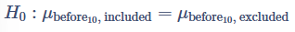
In the sixth section we want to answer the question: do movies with big effects already feature rising breeds? This is similar to our previous test, but we want to determine if the movies chose breeds to be features that were already rising in popularity. This will be comparing the pre-release trends between the movies that authors chose to keep, included movies, and the movies the authors chose not to keep, excluded movies. The case study also only runs one two sample t-test using the 10 year trend change effect with included and excluded as a dummy variable (Ghirlanda). The null and alternative hypothesis are pictured below.

Our two sample t-tests for the 10 year trend change effect for pre-release trends yielded a p-value of 0.1918, a t-value of 1.3243, and a CI of [-245.346, 1191.314]. Our p-value does not satisfy our alpha, our t-value is small, and our CI contains 0, all of which suggest that there is no statistically significant evidence for our alternative hypothesis and we would fail to reject our null hypothesis. Our Bayesian approach yielded a Bayes factor of 0.516, which favours our null hypothesis by about two times, supporting the findings found in our frequentist approach.
Our findings are consistent with the study and that there is no significant difference between the pre-release trends for movies included in the analysis and movies not included in the analysis. This additionally supports the case that the movies could be causation and not correlation.

Section 7:
In this final section I used wilcoxon rank sum tests to answer the question: Do breeds that were rising before the movie show bigger movie effects after the movie? This question is important to compare breeds with positive pre-release trends with breeds with negative pre-release trends, for each effect size. The null and alternative hypotheses are pictured below.

The first test using a one year effect size yielded a p-value of 0.6252, therefore we would fail to reject the null hypothesis. The size of the 1-year movie effect does not depend on whether or not the dog breed was trending upward or downward before the movie.
The second test using a two year effect size yielded a p-value of 0.8776, therefore we would fail to reject the null hypothesis. The size of the 2-year movie effect does not depend on whether or not the dog breed was trending upward or downward before the movie.
The third test using a five year effect size yielded a p-value of 0.2078, therefore we would fail to reject the null hypothesis. The size of the 5-year movie effect does not depend on whether or not the dog breed was trending upward or downward before the movie.
The fourth test using a ten year effect size yielded a p-value of 0.4223, therefore we would fail to reject the null hypothesis. The size of the 10-year movie effect does not depend on whether or not the dog breed was trending upward or downward before the movie.
All four of the Wilcox tests indicate that there was no difference in the trend change effect for breeds that were already rising in popularity before the film. This also confirms that the findings, found in our earlier tests are independent of pre-existing trends. Furthermore, this is consistent with the findings from the case study.

7. Final Conclusions
- Do Movies Increase Dog Breed Popularity?
Yes, across all four post release window’s dog movie appearances produced significant positive
changes in breed registrations.
- Do Year and Audience Size Predict Movie Effects?
For five and ten year effect size, year is a strong negative predictor confirming the long term
influence of movies over time. Opening weekend viewership, or log_viewers, had little to no
significant predictive power in our models.
- What About Total Viewership Instead of Opening Weekend?
Using total viewership instead of opening weekend viewership, there is a similar pattern in both
frequentist and bayesian approaches. Year remained a significant negative predictor for long
term effects, specifically five and ten year trend effects, but total viewership had little to no
significant predictive effect.
- Were Breeds Already Rising Before The Movies?
No. For all four trend change windows, the average pre-release trends were not significantly
different from zero suggesting that none of the breeds featured were already rising before the
movie that featured them as a main character.
- Did Movies With Bigger Effects Feature Breeds Already Rising in Popularity?
No. Both included movies and excluded movies within the study showed no significant difference
when it came to pre-release ten year trends.
- Do Rising/Falling Pre-Release Breeds Show Different Movie Effects?
No. For all trend change windows, the effect sizes were indistinguishable between breeds that
were increasing pre-release and those that were declining.

In Appendix - Visuals there is a plot for each section highlighting key findings throughout the case study analysis.

8. Tools and Environment
- RStudio Markdown Notebook
- Packages: tidyverse, carData, car, easystats, BayesFactor, posterior, performance, MCMCpack, DHARMa, caret, bayestestR, HDInterval, dplyr, tidyr, ggplot2, and broom.

9. Works Cited
Ghirlanda, Stefano, et al. “Dog movie stars and dog breed popularity: A case study in media influence on choice.” PLoS ONE, vol. 9, no. 9, 10 Sept. 2014, https://doi.org/10.1371/journal.pone.0106565.
OpenAI. (2025). ChatGPT [Large language model]. https://chat.openai.com/chat.

10. AI Use Disclosure
Throughout the analysis I used ChatGPT as a resource. I have added footnotes throughout the paper annotating where I have used ChatGPT. I used it to help dissect the case study and to understand what tests were being used in order to structure my analysis appropriately. I used it to help me identify the trend change index used in the case study and understand what that meant. I used it to help me understand odds when the Bayes factors were less than 1, in order to better describe the effect in my paper. I also used it to create the ggplots for each section in order to give a good and effective visualization. Throughout my analysis, I also used ChatGPT in order to understand some of my outputs, specifically Section 6.

11. Appendix - Visuals

Visual for Section 1:
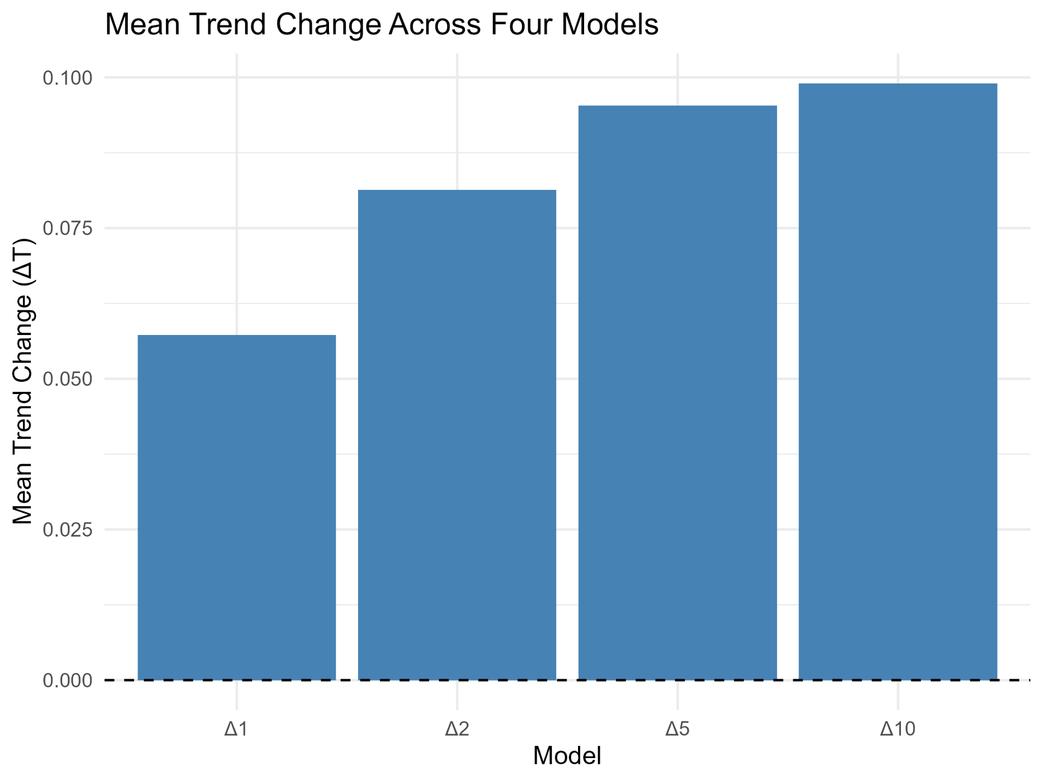
Visual for Section 2:
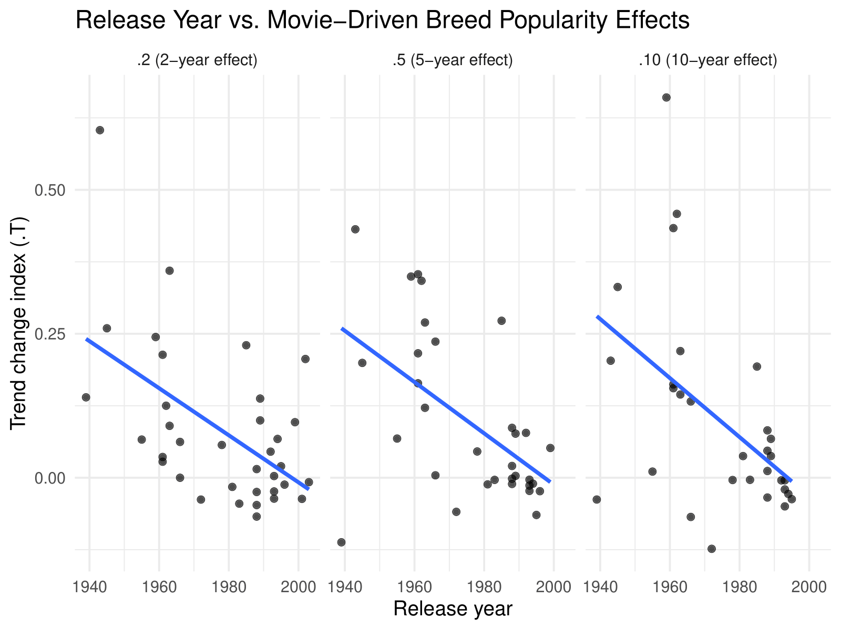

Visual for Section 3:
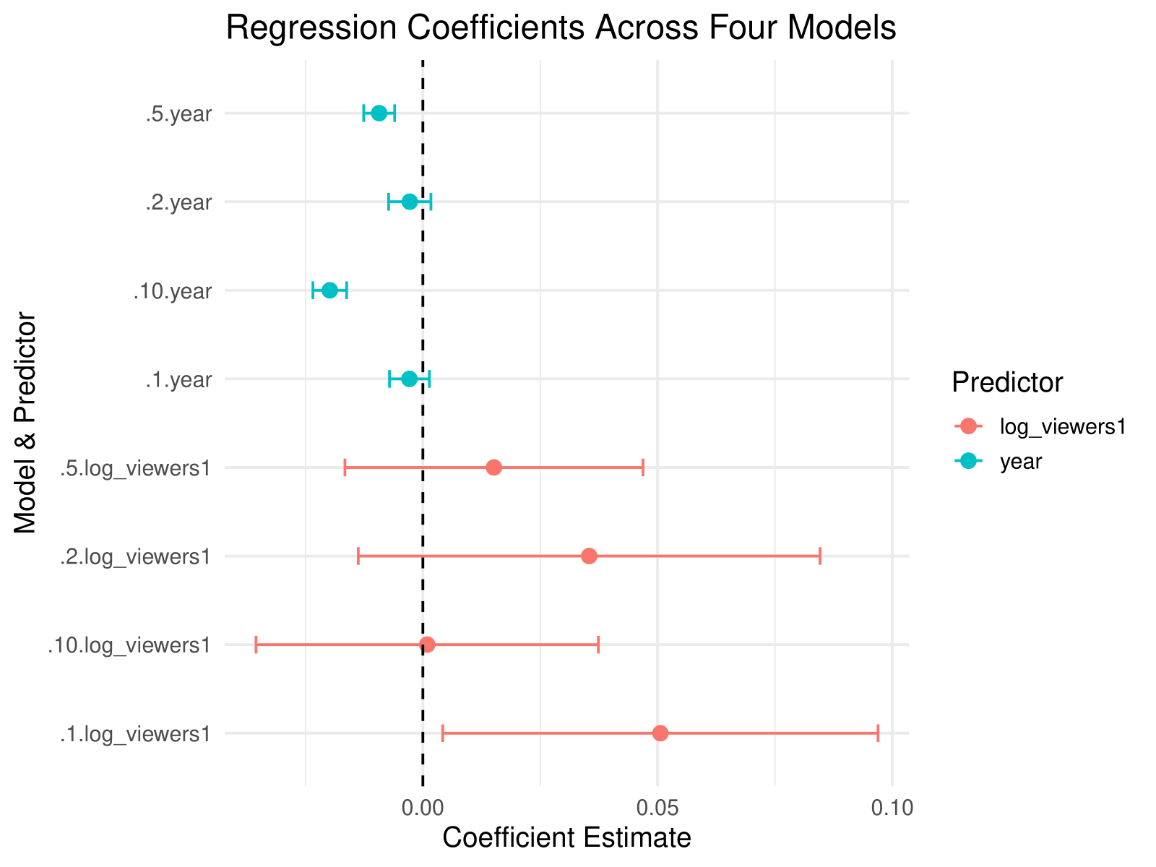

Visual for Section 4:
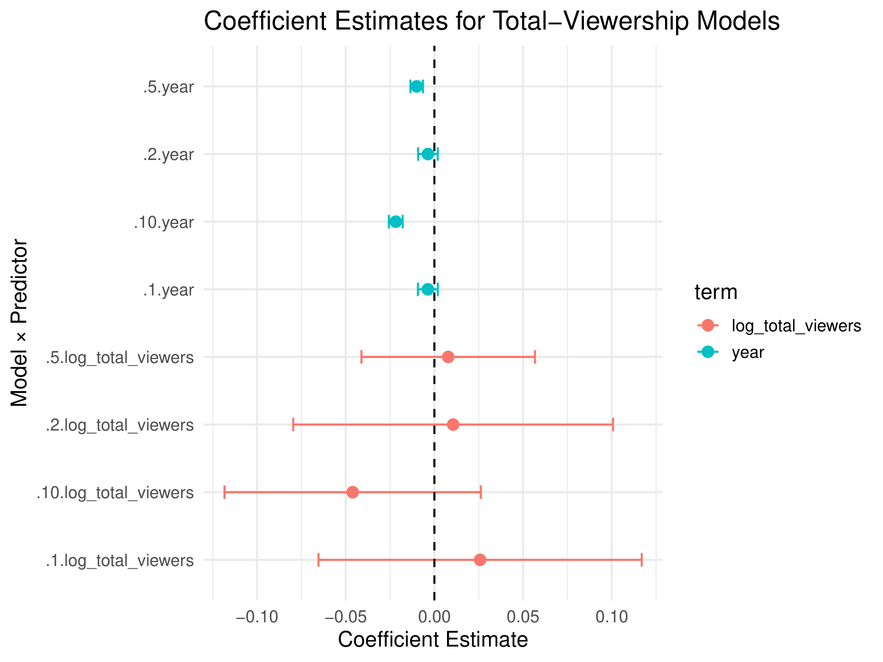

Visual for Section 5:
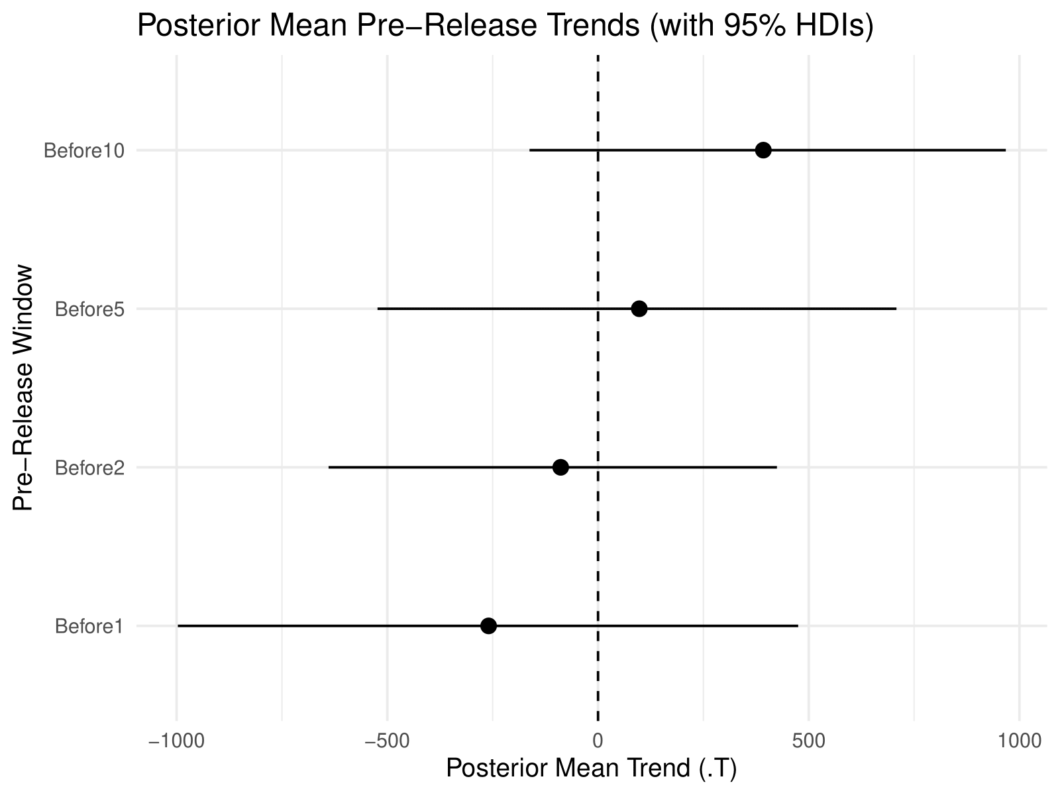

Visual for Section 6:
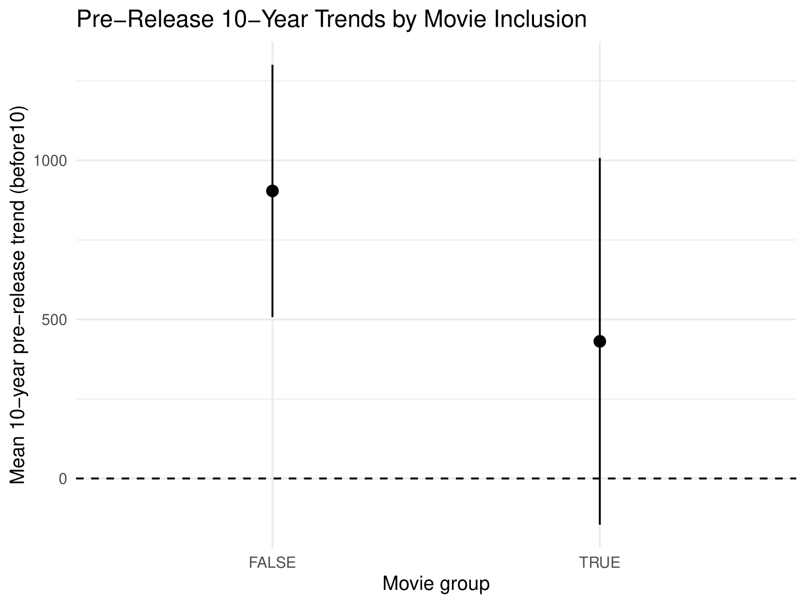

Visual for Section 7:
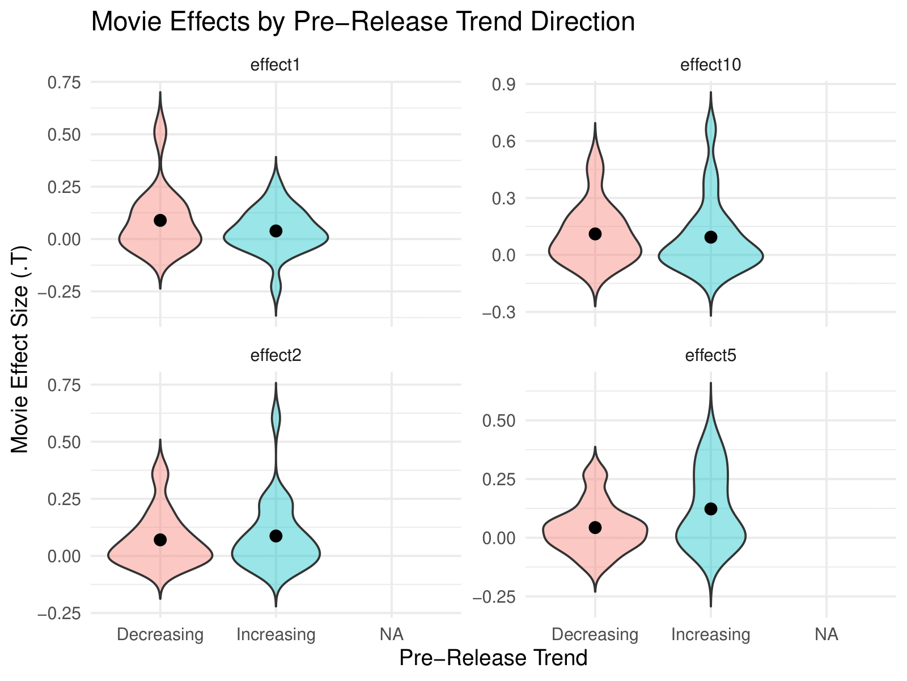

The variable is written as ‘XYear’ due to the 80 observations of different years. Beginning in 1926 and going till 2005. Each variable would be “X1926” or “X2005”.
Submitting the case study as a reference, ChatGPT gave me an overview of what tests were used and a rough outline which I then used to create my outline and project structure.
I used ChatGPT in order to both identify and explain the formula for the trend-change index.
I used ChatGPT in order to identify the correct figures for me to recreate in accordance with the earlier structure guidance.
I used ChatGPT in order to calculate the odds when the Bayes Factors were less than 1. This continues throughout the paper.
I used ChatGPT in order to create all the ggplots for each section. I prompted it with my findings and code and asked what would be the best or most effective visualisation to represent the section as a whole.

